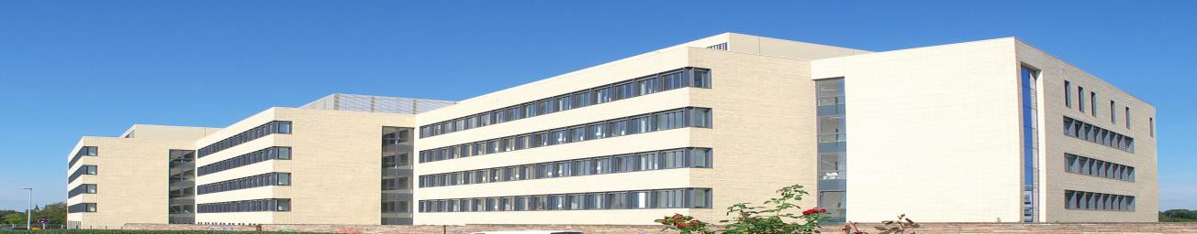

The Functional Architecture of Memory department at the Leibniz Institute for Neurobiology in Magdeburg (Germany; PI Magdalena Sauvage; https://www.lin-magdeburg.org/research/research-units/department-functional-architecture-of-memory) is seeking a highly motivated
Post-doctoral researcher with expertise in-vivo electrophysiology
for a 3-year project (with possible extension) investigating the underlying mechanisms of episodic memory and its content. The project includes in-vivo electrophysiological recordings and optogenetic manipulations. This project is tightly linked to independent subprojects involving high resolution Immediate-early gene imaging, 9.4T fMRI in awake rats and 7TfMRI in humans. The position is available from the 01.12.2022, flexible for the right candidate.
Qualification: The successful candidate will have expertise in in-vivo electrophysiology (single units and LFP recordings), behavioral techniques and be highly motivated by interspecies/interdisciplinary studies. The communication language of the lab is English. The group interacts tightly with the Neural Dynamics laboratory (PI M. Yoshida; in-vitro/vivo electrophysiology & computational neurosciences) as well as with national and international partners including S. Tonegawa (Boston, USA), S. Josselyne (Sickkids, Toronto, CN), J. Csicsvary (IST, Austria), M. Witter (NTNU, Trondheim,NO), E. Duezel (DZNE Magdeburg, Germany) and M. Hoehnn (MPI Cologne, Germany). Candidates of all nationalities are encouraged to apply.
Background of the lab: The department focuses on dissociating the contribution of different medial temporal lobe areas such as CA1, CA3, DG, MEC, LEC, PrC and POR to memory in health, aging and in animal models of amnesia. Memory for time, space and episodes as well as its consolidation/reconsolidation are studied. In nutshell, within this frame, The FAM Dpt has recently identified new spatial and non-spatial subnetworks segregated along the proximodistal axis of the hippocampus (Nakamura et al, J. Neuroscience, 2013; Beer and Vavra et al, Plos biology, 2018; Ku et al, 2021-S-7497-SfN ), hypothesized a network shift between the Trisynaptic loop and the Temporoamonic pathways for the retrieval of memories as they age (Lux et al, Elife, 2016; Atucha et al, bioRxiv, 2021) and depicted memory networks supporting memory reconsolidation (Lux et al, Cerebral cortex, 2017). Techniques include high-order standard or translational human to rat memory tasks (Sauvage et al, Nature Neuroscience, 2008) combined to lesions, optogenetics, high-resolution molecular imaging based on the detection of IEG and in-vivo electrophysiology. fMRI studies in awake rodents (9.4T) and human behavioral studies are also conducted on-site to a lesser extent.
The employment, salary and employee benefits comply with the collective pay agreement (German TV-L). Equal opportunities as well as compatibility of family and work are part of our HR policy. Severely disabled applicants with equivalent occupational aptitude will be considered preferentially.
We are looking forward to your application. Please send a single PDF file comprising a cover letter, a CV, a publication list, names and contact of 3 references and a brief statement of motivation and research interests to jessica.levin@lin-magdeburg.de. Review of the applications will start end of February 2022 and end when the position is filled.
Please note the information for storage of personal data:
https://www.lin-magdeburg.de/fileadmin/user_upload/04_Karriere/Datenschutzhinweise_Bewerber_LIN.pdf

